**Team Information**

**JTR Industries Pty Ltd**

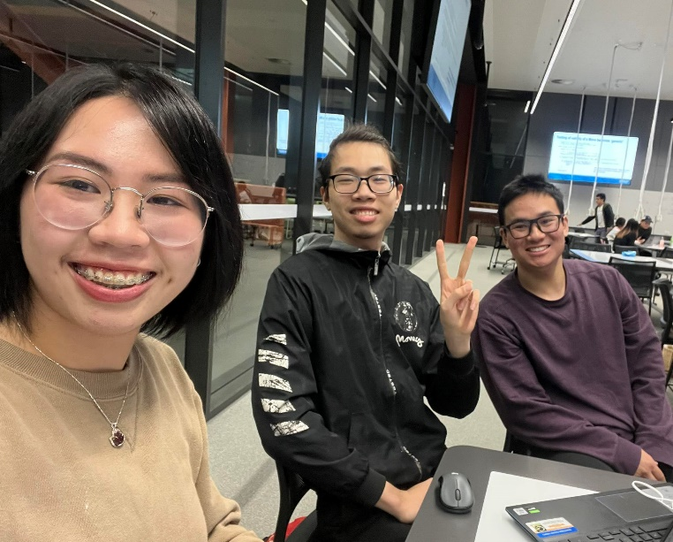

**Last updated: 1/04/2023**

**Table of Contents:**

* Team members
* Team logistics
* Technology stack

**Team members:**

This section details technical information relating to all current members of the company “JTR Industries Pty Ltd”. Contact information is private and intended to be shared only amongst relevant stakeholders and internal company employees.

**Thanh Nguyen (Jessica):**

Jessica Nguyen is a third-year software-engineering student, currently interning at ‘JTR Industries Pty Ltd’. She has had previous experience with agile project management and works well within structured team environments. Jessica has a very keen eye for aesthetics as she also studies design.

*Technical / Professional Strengths:*

* Java
* Javascript
* HTML
* CSS

*Contact details:*

* Email: [tngu0151@student.monash.edu](mailto:tngu0151@student.monash.edu)
* Facebook: <https://www.facebook.com/rubynguyen.1999>

**Tuan Le:**

Tuan Le is a third-year IT student, currently interning at ‘JTR Industries Pty Ltd’. He has had previous experience with agile project management and works well within structured team environments. Tuan is currently writing an epic fantasy novel as a hobby.

*Technical / Professional Strengths:*

* Java
* Javascript
* Python
* HTML
* CSS
* C++

*Contact details:*

* Email: [mlee0096@student.monash.edu](mailto:mlee0096@student.monash.edu)
* Facebook: <https://www.facebook.com/tuan.leminh.18400>

**Ryan Tran**

Ryan Tran is a third-year software-engineering student, currently interning at ‘JTR Industries Pty Ltd’. He has had previous experience with agile project management and works well within structured team environments. In his spare time, Ryan can be found hanging out with his Calico cat, “Kuja”.

*Technical / Professional Strengths:*

* Java
* Javascript
* Python
* HTML
* CSS
* React

*Contact details:*

* Email: [rtra0013@student.monash.edu](mailto:rtra0013@student.monash.edu)
* Facebook: <https://www.facebook.com/ryan.tran.50702/>

**Team logistics:**

This section details the intended meeting schedule for the current project, “Nine Man’s Morris”. It also discusses how division of workload amongst JTR Industries team members will be distributed and managed fairly.

**Meetings:**

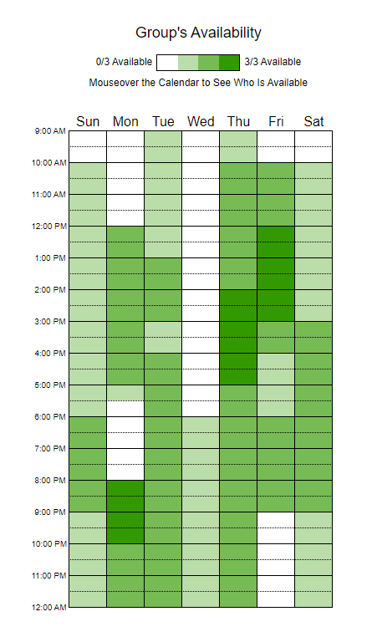*Figure 1. Availability matrix of all JTR Industries members. Created on when2meet.com*

This team will meet regularly in-person at the following times:

* Monday (8:00pm – 9:00pm)
* Thursday (2:00 – 3:00 pm)

These times were chosen based on team member availabilities (see figure 1). These times are especially convenient as they follow in-person applied and consultation sessions.

Please note that additional meetings may be organized on a week-to-week basis, dependant on workload.

**Division of workload:**

Workload will be distributed evenly amongst team members at the start of each sprint. Team members will meet in person after identifying all user stories pertaining to the current sprint.

User stories and features will then be assigned to team members, taking into consideration the complexity and nature of the work.

Care will be taken during this meeting to ensure each member does an appropriate amount across all facets of the project (documentation, coding, wireframing etc.).

**Technology stack:**

This section details the proposed technology stack to be used for the “Nine Man’s Morris” project. Included is the justification for each choice and alternative considerations.

Program language:

* Java

Java was chosen as the main programming language for this project due to several reasons. Primary amongst them, was because all members of JTR Industries have had previous experience coding with Java

Potential APIs:

* Java2d
* Swing
* SDLJava

Programming Platform:

* IntelliJ IDEA CE

Design:

* Figma
* Lucidchart

Version Control:

* Gitlab

Team Name: JTR

Team Photo:

Team Member Information

Name: THANH NGUYEN (JESSICA)

Contact details:

- Email: tngu0151@student.monash.edu

- Facebook: Jessica Nguyen

Technical and Professional strength:

- Art related tasks, because I study Design.

- IT strength: java, javascript, html and css

Name: RYAN TRAN

Contact details:

- Email: rtra0013@student.monash.edu

- Facebook: https://www.facebook.com/ryan.tran.50702/

Technical and Professional strength:

- IT strength: java, javascript, html, python, react and css

Fun fact:

- I have a pet cat named Kuja

Name: TUAN LE

Contact details:

- Email: mlee0096@student.monash.edu

- Facebook: https://www.facebook.com/tuan.leminh.18400

Technical and Professional strength:

- IT strength: java, javascript, html, python, C++, and CSS

Fun fact:

- I am practising writing a fantasy novel as a hobby

Team Schedule

Monday after class 8pm

Thursday 2pm

Workload will be distributed by, identifying user stories as a team prior to each sprint,

then dividing user stories for implementation evenly across all team members (taking into consideration

workload).

Technology Stack and Justification

*note: ask for APIs; UI requirement; does game need to save games?; ask feedback; do we need a menu?

Program language: Java

Programming platform: IntelliJ IDEA CE

UI design: Figma